**RIPHAH INTERNATIONAL UNIVERSITY, ISLAMABAD**



**Lab 8**

**Bachelors of Computer science – 5th semester**

**Subject:** Operating System Lab

**Submitted to:** Ma’am Kausar Nasreen Khattak

**Submitted by:** Munaza Malik

**Sap Id:** 44956

**Date:** 8th October, 2024

**Lab Task:**

**Q1.**

Write a C/C++ program that uses the fork() function and the logical AND (&&) operator.

**Answer:**

The Fork system call is used for creating a new process in Linux, and Unix systems, which is called the child process, which runs concurrently with the process that makes the fork() call (parent process). After a new child process is created, both processes will execute the next instruction following the fork() system call. Now here in this case we use conditional statement or AND operator.

If both conditions are true then it will proceed further. Code executes parent and child occur parent receives positive value and child receive negative. After the parent, two more processes generate the child and parent now from parent to parent we have 1 then statement execute on the other hand again process creates parent and child the second time execute.

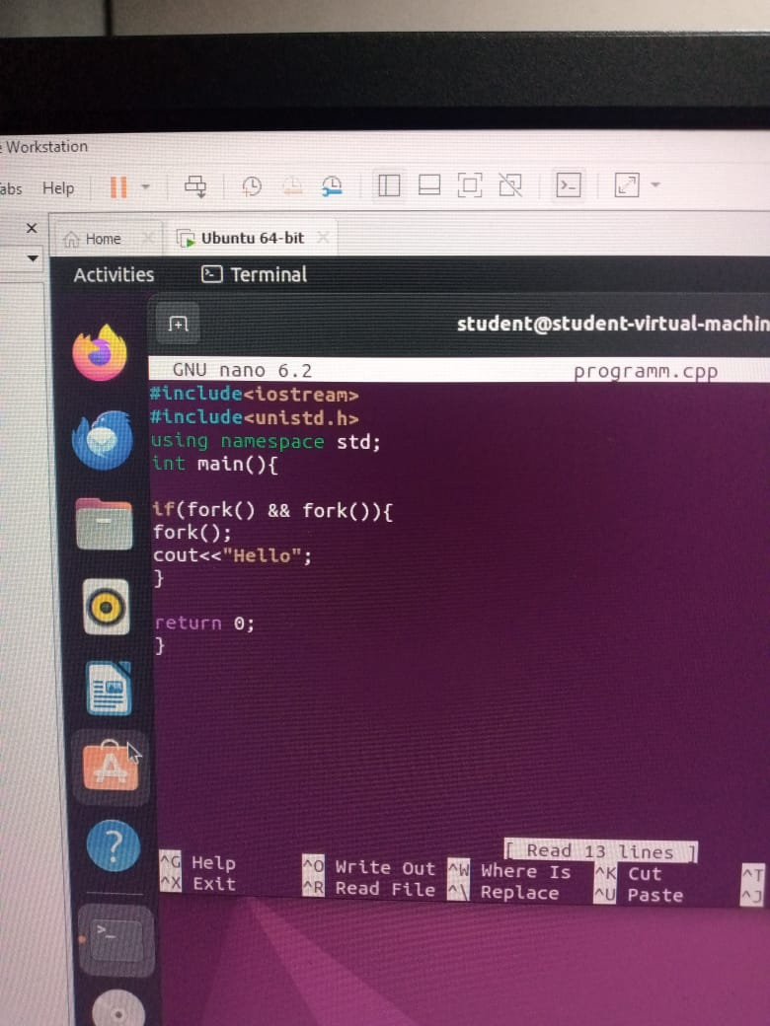

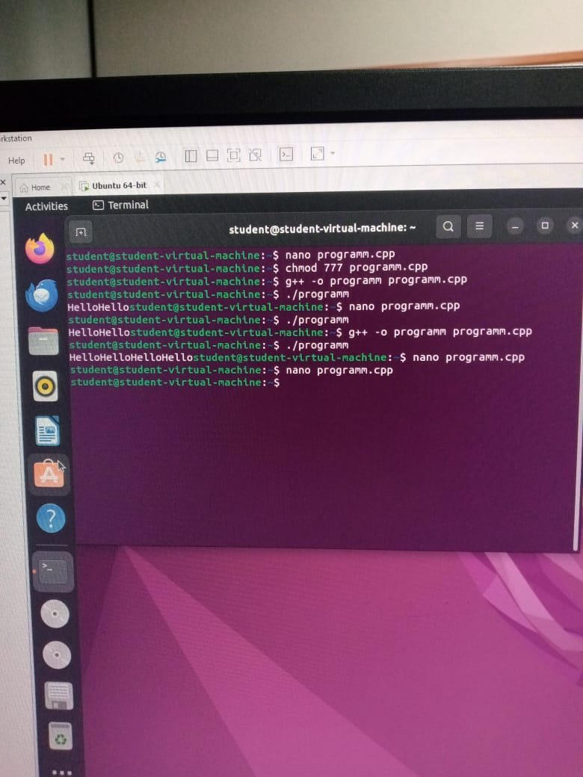

**Q2.**

Write a C/C++ program that uses the fork() function and the logical OR (II) operator.

**Answer:**

In the OR operator if any of one is true, the result will be true then it will proceed. The first fork creates child (0) and parent (1). The second fork is called for both Parent (1) and child (1). Then Parent (1) will be divided into Child (0) and Parent (1) and Child (1) will be divided into Child (0), and Child (0). One condition in child (1) is true (0+1=true). It will further divide into Child (0) and Child (0) this is the last call of fork. In this way 4 times Hello is printed.

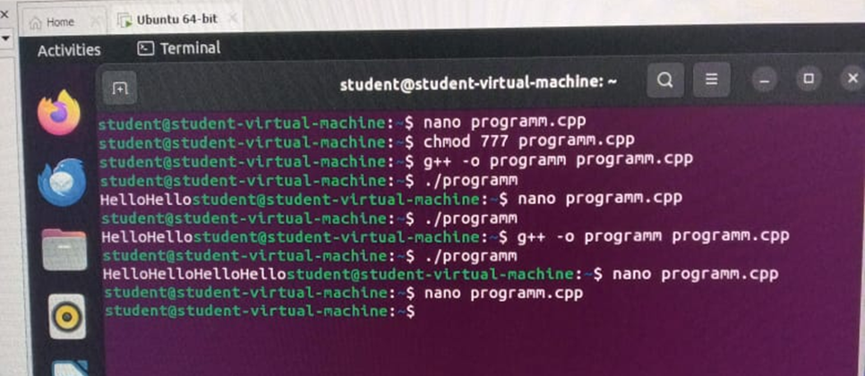

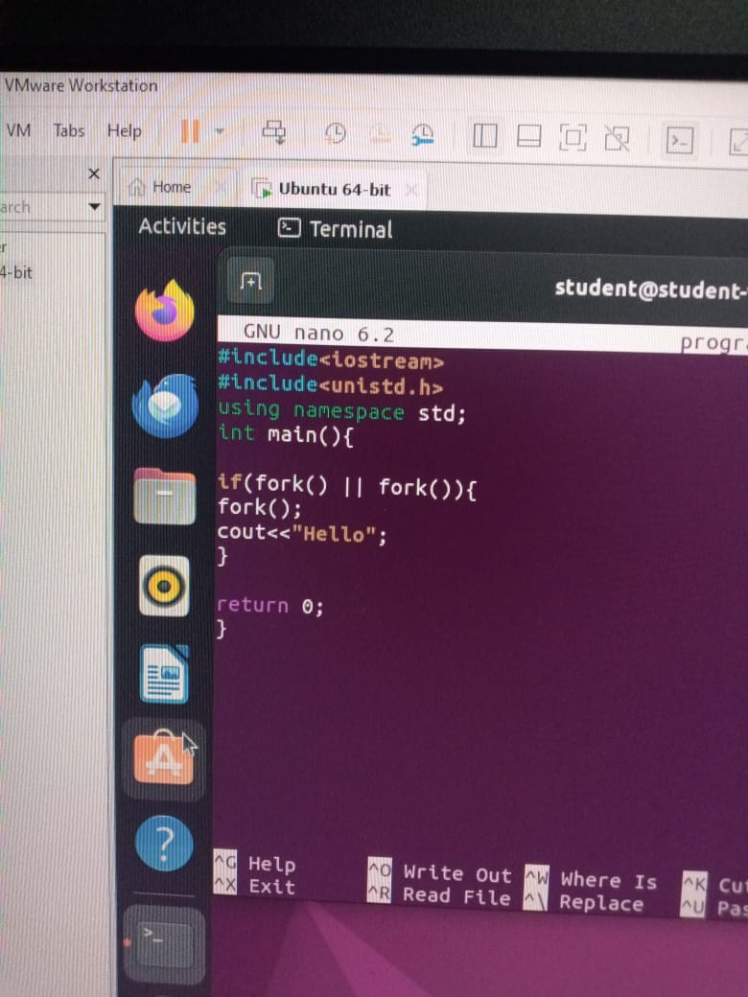

**Q3.**

Write a C++ program that uses fork() to create a child process. Use an if-else statement.

**Answer:**

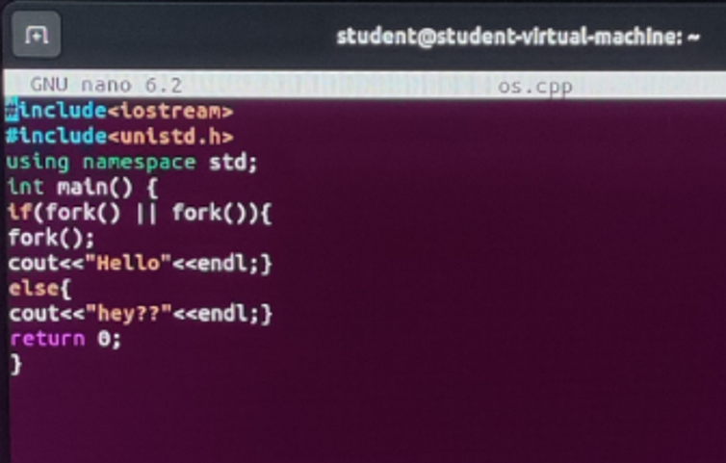

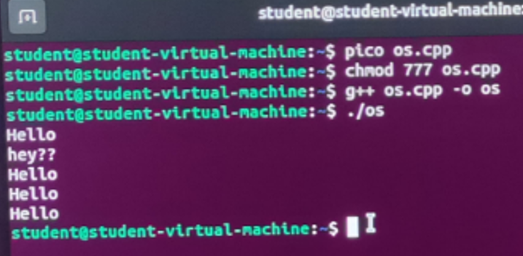

In this program, we have used the OR operator with the if else case means if the fork fails then the else case will run. OR operator will work if one of the conditions is false it will false.

Fork () creates a new process (child process) that runs the same code as the parent process but

independently. The || (OR) operator means that if either of the fork () calls creates a child

process (i.e., returns 0), the condition becomes true. This leads to running the code inside the

if block. If the condition is true, a third fork () is called, creating another child process.

else block:

If the condition is false (both fork () calls return 0).